PROJECT TITLE
Fake News Blocker – AI-Based Fake News Classification System

Submitted for
Exploration & Seminars in AI
ABAI1009P

Submitted by:
Vinayak Jain, Sai, Hardik
Roll No: AR25ARIU0013
A25ARIU0011
A25ARIU0018

Submitted to:
Dr. Shakshi Sharma

July–Dec 2025
School of Artificial Intelligence


INDEX
Sr. No | Content | Page No
1 | Abstract | __2_
2 | Introduction | __2_
3 | Related Work | __2_
4 | Methodology | __3_
5 | Hardware/Software Required | __3_
6 | Experimental Results | __4_
7 | Conclusions | __7_
8 | Future Scope | _7__
9 | GitHub Link | _8__

Abstract
Fake news spreads rapidly on social platforms and creates misinformation among the public. This project presents an AI-based Fake News Blocker that classifies news articles as Fake or Real using Natural Language Processing (NLP) and Machine Learning (ML). The system uses TF-IDF for text vectorization and Logistic Regression for classification. A Flask-based web interface is deployed locally to allow users to test news articles easily. The model achieves high accuracy (≈98.9%) and demonstrates a complete end-to-end ML workflow from data preparation to deployment.

Introduction
With the rise of digital media, fake news has become a widespread problem. People often struggle to differentiate between authentic and false information. Machine Learning offers an automated way to analyze and classify news based on textual patterns.
This project aims to build a Fake News Detection system using Logistic Regression and deploy it using a Flask web application. Users can enter any news text and instantly receive a prediction.

Related Work
Fake news detection using machine learning has been widely studied. Common approaches:
- Bag-of-Words & TF-IDF for text transformation
- Logistic Regression for classification
- Deep learning models (LSTM, BERT) for context-aware detection
This project implements the classical and effective TF-IDF + Logistic Regression pipeline.

Methodology

1. Dataset
- Two datasets: Fake.csv and True.csv
- Combined total ≈ 45,000 articles
- Labels: Fake = 1, Real = 0

2. Data Preprocessing
- Lowercasing
- Removing punctuation
- Removing unwanted symbols
- Cleaning text for ML

3. Feature Extraction (TF-IDF)
- Converts text to numerical vectors
- Highlights important words
- Used 5000 max features

4. Model Training
- Algorithm: Logistic Regression
- Train-test split: 80/20

5. Model Evaluation
- Accuracy: ≈98.9%
- Precision, recall, F1-score all near 0.99
- Confusion matrix shows excellent performance

6. Deployment (Flask)
- Localhost: http://127.0.0.1:5000
- User pastes news → Model predicts Fake/Real
- Uses saved .pkl files

Hardware/Software Required

Hardware
- Laptop/PC with minimum 4GB RAM
- No GPU required

Software
- Python 3.14
- Libraries:
  - Flask
  - Pandas
  - NumPy
  - Scikit-Learn
  - Seaborn
- VS Code
- GitHub account

Experimental Results

1. Dataset Visualization
- Bar chart shows Fake vs Real distribution

2. Model Performance
- Accuracy: ~0.989
- Strong precision, recall, and F1-score

3. Confusion Matrix
- Very low misclassification rate

4. Flask Output
- Predicts Fake/Real from user input successfully
- 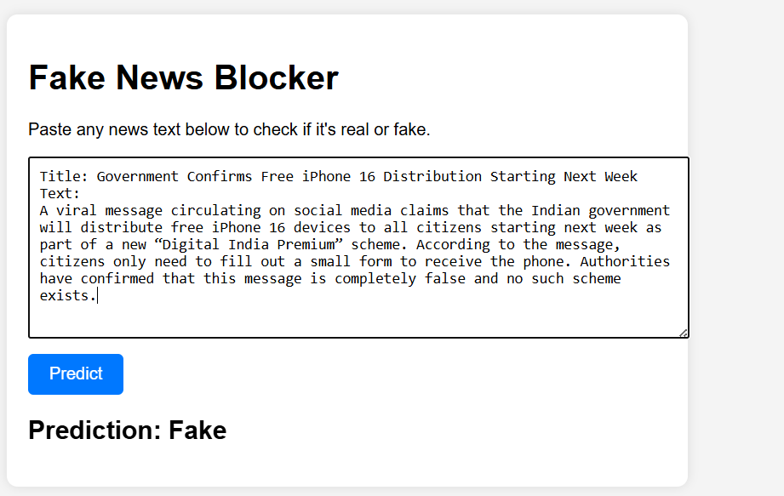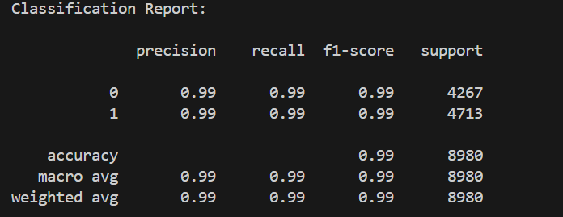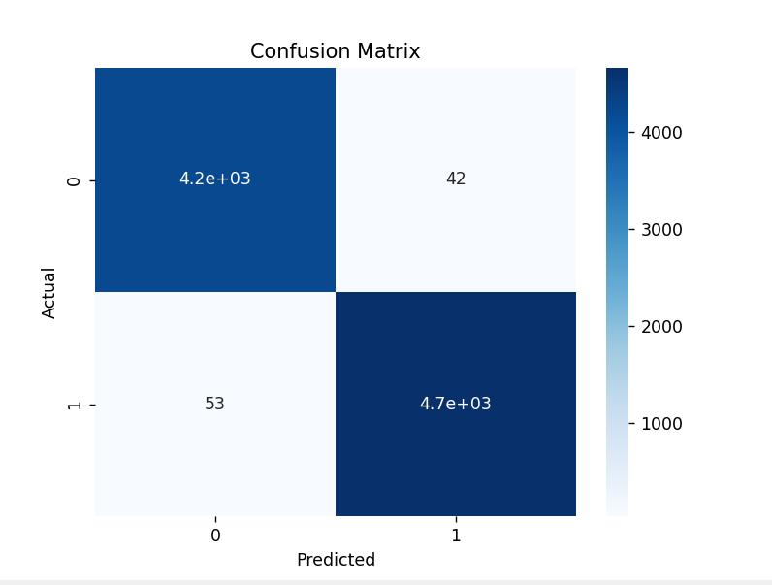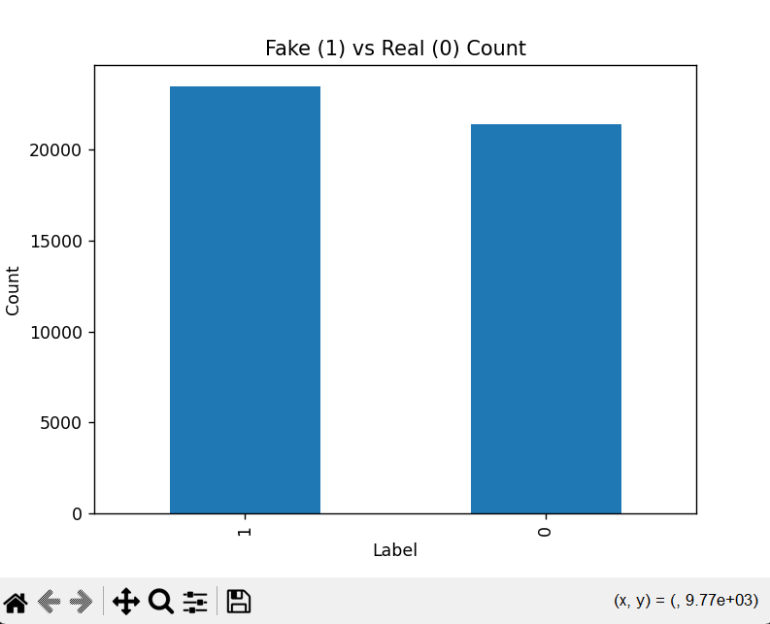

Conclusions
The Fake News Blocker successfully identifies fake and real news using machine learning. The TF-IDF + Logistic Regression model performs extremely well, achieving high accuracy and reliability. Flask deployment allows real-time text classification. The project demonstrates a complete ML pipeline from preprocessing to deployment and serves as an effective tool for misinformation detection.

Future Scope
- Use advanced models (LSTM, BERT, Transformers)
- Deploy the application online
- Multi-language fake news detection
- Real-time scraping and news verification
- Browser extension for instant detection

GitHub Link of Your Complete Project
https://github.com/Vinayakjain7/Fake-News-Blocker.git

